Cloud Computing Lab Week 10
PES1201802127
Siddharth K Rao

Task 1:

1a.png: Showing 2 S3 buckets created , one having the original image and another S3 bucket suffixed with -resized to store thumbnails
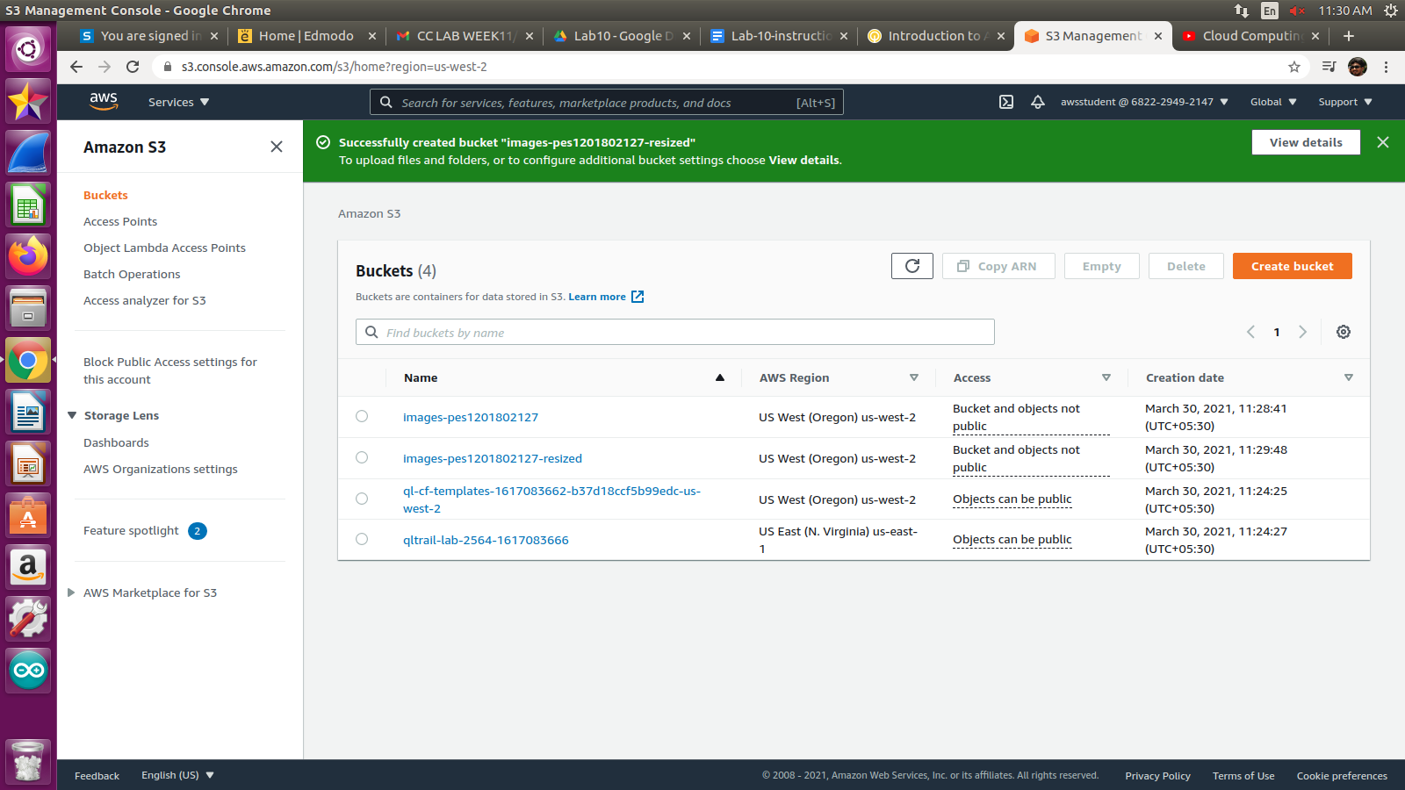

1b.png: Showing the Designer tab diagram, showing that S3 will trigger the creation of the create-thumbnail function

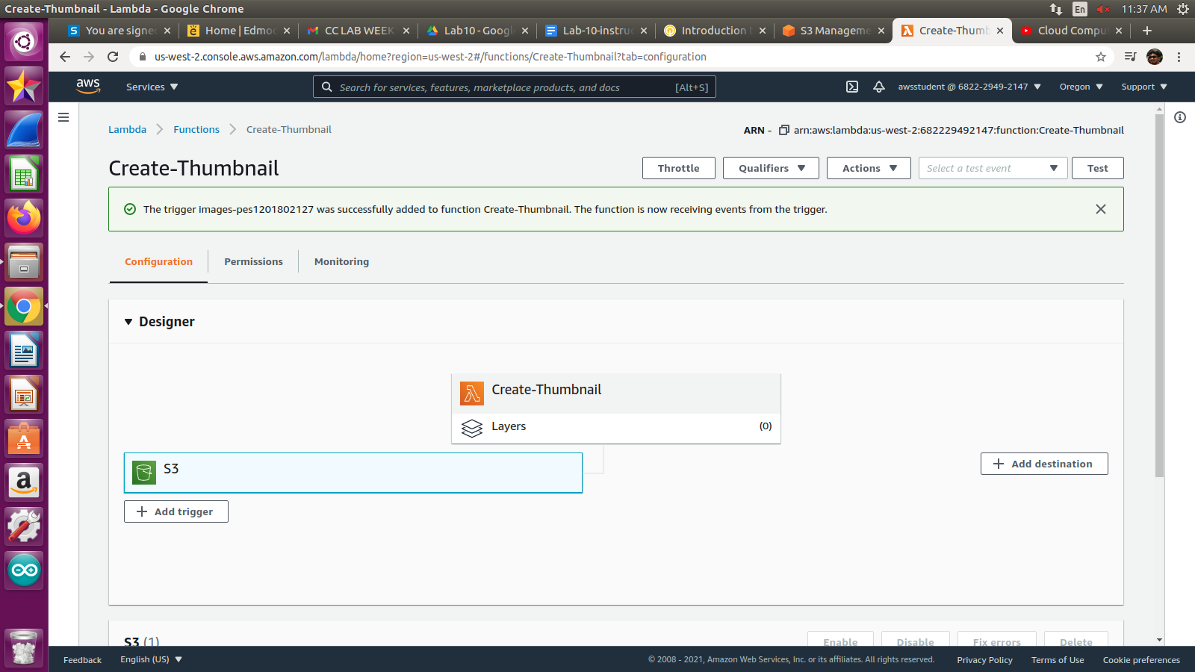

1c.png: Test run successfully

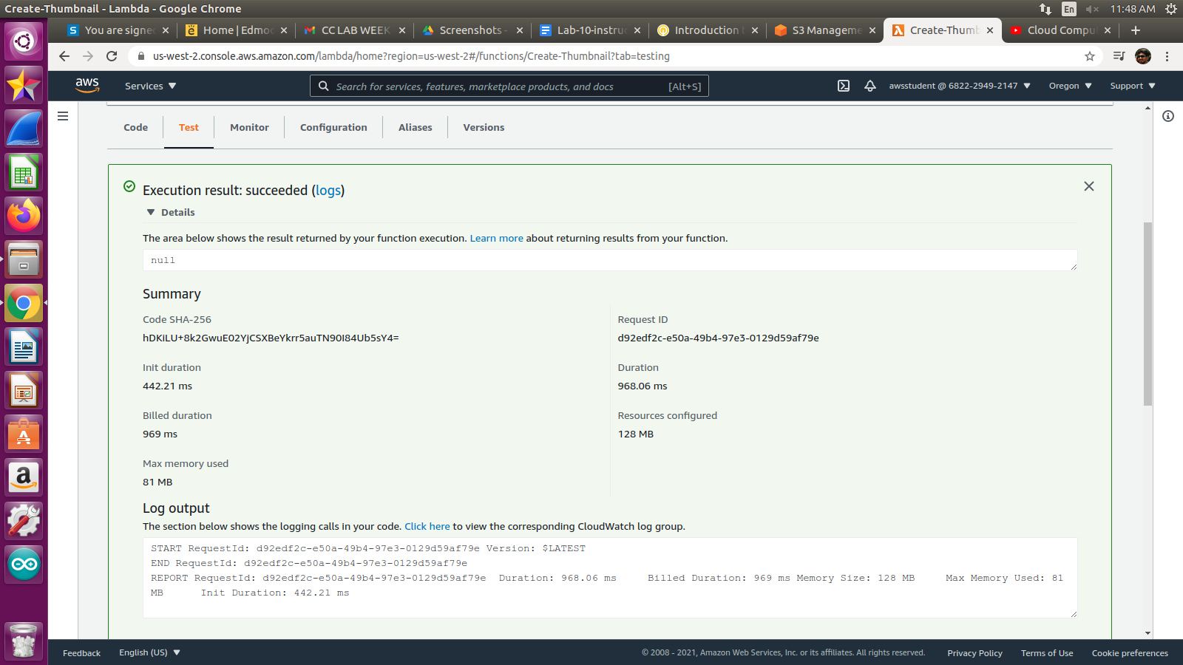

1d.png: Thumbnail created in the -resized S3 bucket.

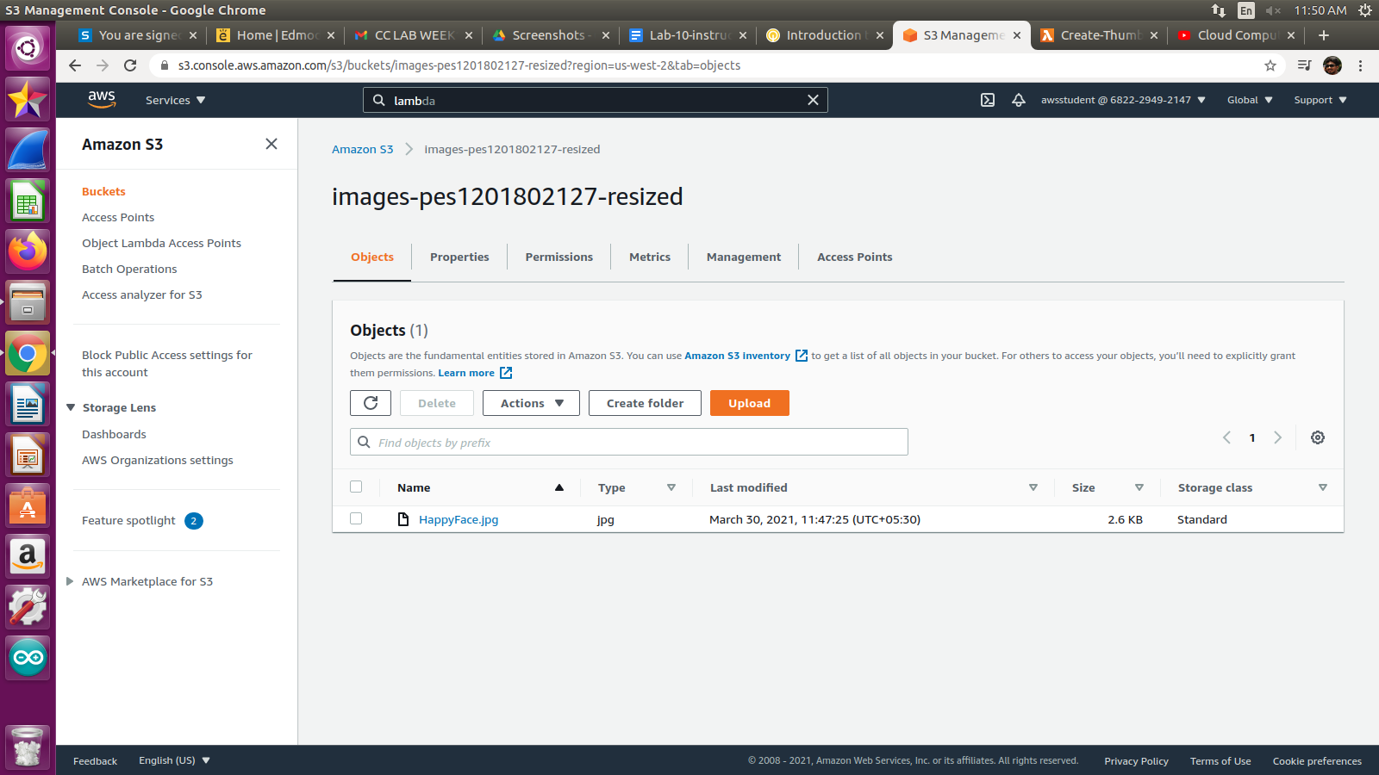

Task 2:

2a.png: Showing the Designer tab diagram, showing that API Gateway will trigger the creation of the create-thumbnail function

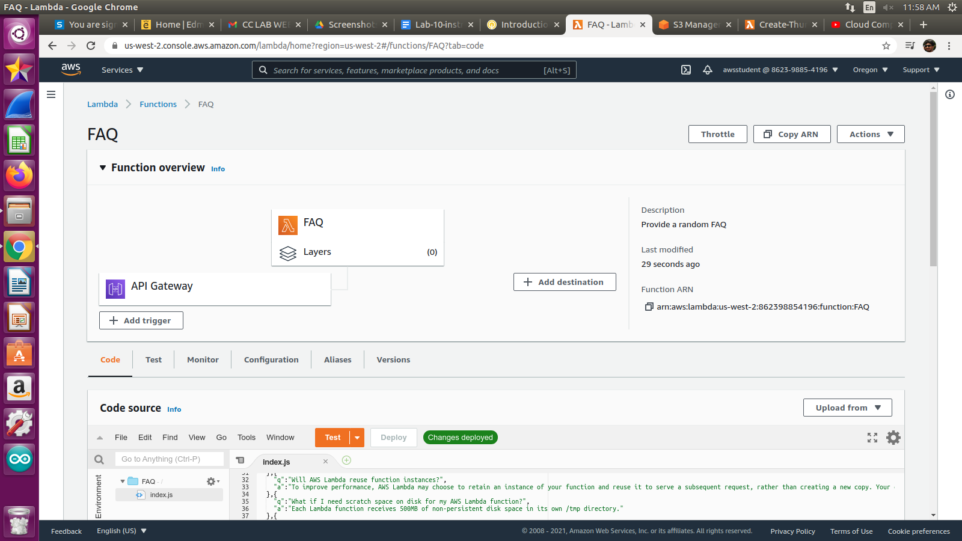
2b.png: Screenshot of accessing the API Endpoint URL on browser and getting successful response

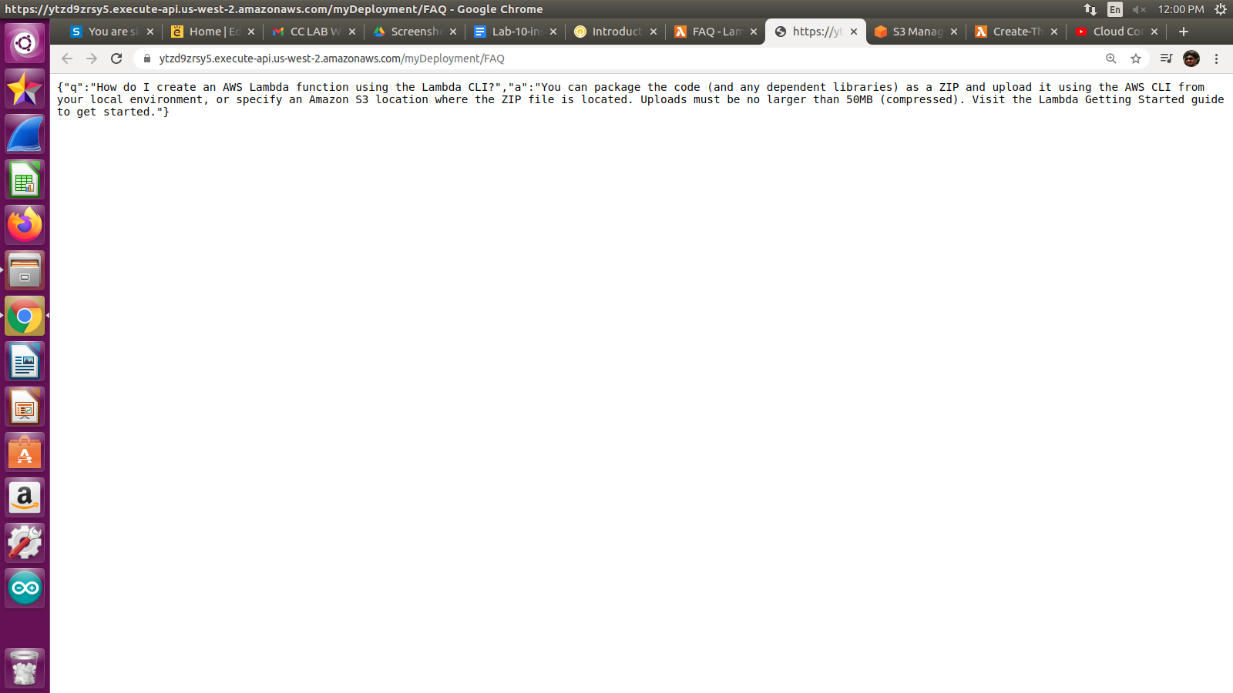

2c.png: Test run successfully

